**TCRT5000 LINE TRACKING SENSOR**

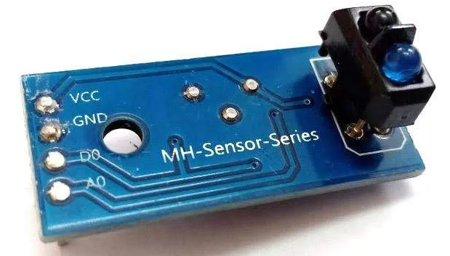

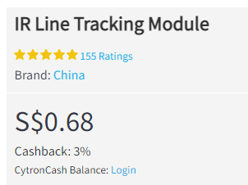<https://sg.cytron.io/p-ir-line-tracking-module>

**IR Line Tracking Module consists of a IR reflex sensor, it is a sensor with optoelectronic transmitter and receiver in a package. It functions by illuminating a surface with infrared light; the sensor then picks up the reflected infrared radiation and, based on its intensity, determines the reflectivity of the surface in question. Lightly colored surfaces will reflect more light than dark surfaces; therefore, lightly colored surfaces will appear brighter to the sensor. This allows the sensor to detect a dark line on a pale surface, or a pale line on a dark surface.**

[**https://www.gie.com.my/download/um/modules/sensor/um_line_tracking.pdf**](https://www.gie.com.my/download/um/modules/sensor/um_line_tracking.pdf)

**How to attach sensors to the robot**

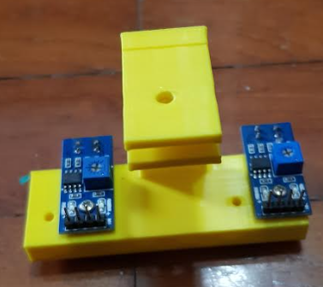

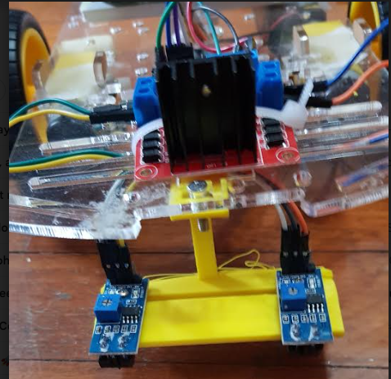

**DEMONSTRATION OF HOW THE SENSOR WORK**